FoodExpress Order Recovery Initiative
Jayesh Malviya
CoachX
Business Analysis Report
EXECUTIVE
SUMMARY
FoodExpress is a leading food delivery platform operating across multiple cities in India. During the first quarter of 2026, management observed a significant decline in order volume within the Indore market. Analysis of preliminary business reports indicated that total orders decreased by approximately 20% over the last three months, while other cities maintained relatively stable performance.
The decline in orders has resulted in reduced revenue, lower customer engagement, decreased restaurant activity, and potential loss of market share to competitors. Since the exact causes of the decline are unknown, FoodExpress has initiated a business analysis project to investigate the issue, identify contributing factors, and recommend corrective actions.
The objective of this initiative is to perform a comprehensive assessment of customer behavior, operational performance, restaurant partnerships, marketing effectiveness, and competitive activity in order to identify the root causes of the decline and propose data-driven solutions for business recovery.
The outcome of this project will include a Root Cause Analysis Report, Business Requirements Document, Executive KPI Framework, and a set of strategic recommendations aimed at restoring order growth in the Indore market.

PROBLEM
STATEMENT
FoodExpress has experienced a 20% decline in order volume in Indore over the past three months. The reduction in order volume has negatively impacted revenue generation, customer retention, restaurant engagement, and overall business performance.
Currently, management lacks sufficient visibility into the underlying factors responsible for the decline. Potential contributing factors may include operational inefficiencies, increased delivery times, customer dissatisfaction, restaurant attrition, reduced marketing effectiveness, competitive pressure, or technology-related issues.
Without identifying and addressing the root causes, the decline may continue and further impact the company's market position in Indore.
Therefore, a structured business analysis initiative is required to investigate the issue, identify root causes, and recommend corrective actions.

BUSINESS
OBJECTIVES
The primary objectives of this project are:
BO-01
Identify the root causes contributing to the 20% decline in order volume within the Indore market.
BO-02
Assess the impact of customer behavior, delivery operations, restaurant partnerships, marketing activities, and competitive factors on business performance.
BO-03
Establish a framework for monitoring key business performance indicators at the city level.
BO-04
Recommend actionable business and operational improvements to recover lost order volume.
BO-05
Improve decision-making capabilities through enhanced reporting and performance visibility.
BO-06
Support management in achieving sustainable growth and customer retention within the Indore market.
STAKEHOLDER
REGISTER
Stakeholder |  |  |  | Role |  |  |  | Interest in Project |  |  |  |  | Influence |  |  |  |  |  | Why Involved
CEO |  |  |  | Project Sponsor |  |  |  | High |  |  |  |  | High |  |  |  |  |  | Wants revenue recovery
Regional Operations Head |  |  |  | Business Owner |  |  |  | High |  |  |  |  | High |  |  |  |  |  | Responsible for city performance
Operations Manager |  |  |  | Process Owner |  |  |  | High |  |  |  |  | Medium |  |  |  |  |  | Manages delivery operations
Marketing Manager |  |  |  | Functional Stakeholder |  |  |  | High |  |  |  |  | Medium |  |  |  |  |  | Responsible for customer acquisition
Customer Support Manager |  |  |  | Functional Stakeholder |  |  |  | Medium |  |  |  |  | Medium |  |  |  |  |  | Handles customer complaints
Restaurant Success Manager |  |  |  | Functional Stakeholder |  |  |  | High |  |  |  |  | Medium |  |  |  |  |  | Manages restaurant relationships
Delivery Partner Manager |  |  |  | Functional Stakeholder |  |  |  | High |  |  |  |  | Medium |  |  |  |  |  | Responsible for driver network
Data Analyst |  |  |  | SME |  |  |  | Medium |  |  |  |  | Low |  |  |  |  |  | Provides business insights
Customers |  |  |  | End Users |  |  |  | High |  |  |  |  | Low |  |  |  |  |  | Experience service issues
Restaurant Partners |  |  |  | External Stakeholders |  |  |  | High |  |  |  |  | Low |  |  |  |  |  | Provide food services
Delivery Partners |  |  |  | External Stakeholders |  |  |  | Medium |  |  |  |  | Low |  |  |  |  |  | Execute deliveries

- STAKEHOLDER MATRIX (POWER VS INTEREST)

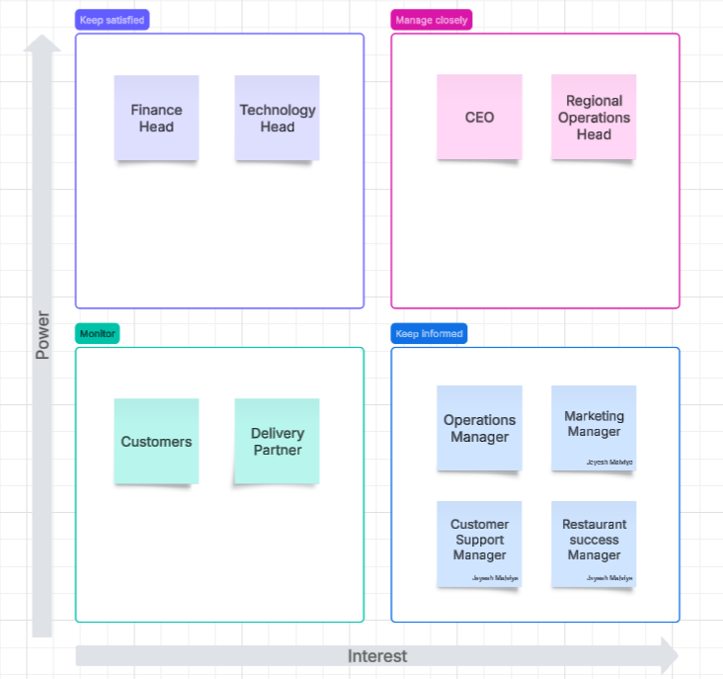

CONDUCTED
INTERVIEW

Interview 1 – CEO
Objective
Understand business concerns and success expectations.
Questions
- What business impact has the order decline created?
- When was the decline first noticed?
- Which KPI concerns you most?
- What outcome would make this project successful?
- Are there any budget or timeline constraints?
Expected Findings
- Revenue impact
- Growth targets
- Executive expectations

Interview 2 – Regional Operations Head
Objective
Understand city-level operational performance.
Questions
- Which areas of Indore are most affected?
- Has delivery performance changed recently?
- Any changes in operational processes?
- Have cancellation rates increased?
- Have driver shortages been observed?
Expected Findings
- Operational bottlenecks
- Regional trends

Interview 3 – Marketing Manager
Objective
Understand customer acquisition and retention performance.
Questions
- Have marketing budgets changed recently?
- How are campaigns performing?
- Any change in customer acquisition rates?
- What is the repeat order trend?
- Have competitors launched new promotions?
Expected Findings
- Marketing effectiveness
- Competitive pressure

Interview 4 – Customer Support Manager
Objective
Understand customer pain points.
Questions
- What are the top complaint categories?
- Have complaints increased recently?
- Are complaints concentrated in certain zones?
- Are delivery complaints increasing?
- What feedback do customers provide most often?
Expected Findings
- Customer dissatisfaction drivers

Interview 5 – Restaurant Success Manager
Objective
Understand restaurant partner issues.
Questions
- How many restaurants have left recently?
- Why are restaurants leaving?
- Any complaints about platform operations?
- Are restaurants experiencing reduced order volume?
- Are competitors approaching restaurant partners?
Expected Findings
- Restaurant attrition causes

Interview 6 – Delivery Partner Manager
Objective
Understand delivery partner performance.
Questions
- Has driver attrition increased?
- Are drivers rejecting orders more often?
- Any recruitment challenges?
- Which zones have driver shortages?
- What concerns do delivery partners raise?
Expected Findings
- Driver availability issues
- Retention concerns

DATA
ANALYSIS

1. ORDER TREND ANALYSIS

Month |  |  |  |  |  | Orders
January |  |  |  |  |  | 50,000
February |  |  |  |  |  | 47,000
March |  |  |  |  |  | 44,000
April |  |  |  |  |  | 40,000
Observation
- Total decline = 20%
- Continuous month-over-month reduction
- Indicates a sustained issue rather than a one-time event
Business Impact
- Revenue decline
- Reduced platform engagement
- Potential customer churn

2. Revenue Trend Analysis

Month |  |  |  |  |  | Revenue (₹)
January |  |  |  |  |  | 1.5 Cr
February |  |  |  |  |  | 1.42 Cr
March |  |  |  |  |  | 1.31 Cr
April |  |  |  |  |  | 1.20 Cr
Observation
Revenue declined alongside order volume.
Business Impact
Reduced profitability and lower city performance.

3. Customer Retention Analysis
Month |  |  |  |  |  |  |  | Retention Rate
January |  |  |  |  |  |  |  | 78%
April |  |  |  |  |  |  |  | 65%
Observation
Customer retention dropped by 13%.

4. Delivery Performance Analysis
Month |  |  |  |  |  |  |  | Avg Delivery Time
January |  |  |  |  |  |  |  | 32 mins
February |  |  |  |  |  |  |  | 36 mins
March |  |  |  |  |  |  |  | 41 mins
April |  |  |  |  |  |  |  | 46 mins
Observation
Delivery time increased by 44%.
Business Impact
- Customer dissatisfaction
- Increased cancellations
- Negative reviews

5. Driver Availability Analysis
Month |  |  |  |  |  |  | Active Drivers
January |  |  |  |  |  |  | 1,200
April |  |  |  |  |  |  | 840
Observation
Driver availability decreased by 30%.
Business Impact
- Longer delivery times
- Delayed order fulfilment

6. Restaurant Partner Analysis
Month |  |  |  |  |  |  |  | Active Restaurants
January |  |  |  |  |  |  |  | 850
April |  |  |  |  |  |  |  | 790
Observation
60 restaurants left the platform.
Business Impact
- Reduced food options
- Lower customer choice
- Reduced platform attractiveness
7. Customer Complaint Analysis
Complaint Category |  |  |  |  |  |  |  | Percentage
Late Delivery |  |  |  |  |  |  |  | 42%
High Delivery Charges |  |  |  |  |  |  |  | 25%
Missing Items |  |  |  |  |  |  |  | 15%
Food Quality |  |  |  |  |  |  |  | 10%
App Issues |  |  |  |  |  |  |  | 8%
Observation
Late delivery is the most common complaint.
Business Impact
Direct impact on customer satisfaction.

8. Marketing Analysis
Metric |  |  |  |  | January |  |  |  |  |  | April
Marketing Spend |  |  |  |  | ₹25 Lakh |  |  |  |  |  | ₹17 Lakh
New Customers |  |  |  |  | 8,000 |  |  |  |  |  | 5,200
Observation
Marketing budget reduced by approximately 32%.
Business Impact
Fewer new customer acquisitions.

FINDINGS
SUMMARY
Area |  |  |  |  | Finding
Orders |  |  |  |  | Declined by 20%
Revenue |  |  |  |  | Declined by 20%
Retention |  |  |  |  | Reduced from 78% to 65%
Delivery Time |  |  |  |  | Increased by 44%
Drivers |  |  |  |  | Reduced by 30%
Restaurants |  |  |  |  | Reduced by 60 partners
Marketing |  |  |  |  | Spend reduced by 32%
Complaints |  |  |  |  | Late delivery highest complaint

GAP
ANALYSIS
KPI | Current State | Desired State | Gap
Monthly Orders | 40,000 | 50,000 | -10,000
Retention Rate | 65% | 80% | -15%
Delivery Time | 46 mins | 30 mins | +16 mins
Active Drivers | 840 | 1,200 | -360
Active Restaurants | 790 | 850 | -60
ROOT CAUSE
ANALYSIS (RCA)

Objective
Identify the underlying factors responsible for the 20% decline in order volume in Indore.

- Fishbone (Ishikawa) Analysis

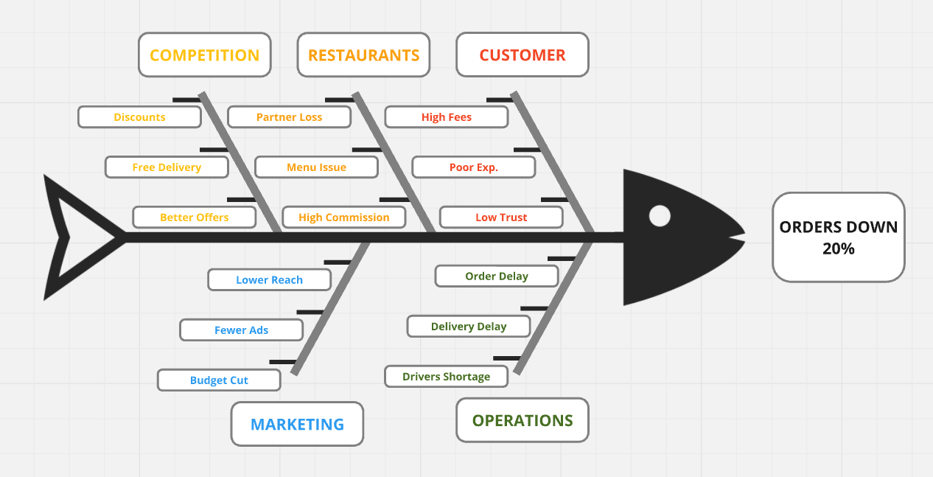

Observation
From stakeholder interviews and data analysis, the strongest contributing factors appear under:
Operations
- Driver shortage
- Delivery delays
Restaurants
- Partner attrition
Marketing
- Reduced acquisition
Competition
- Aggressive offers

- 5 Whys Analysis

Investigate the largest issue first.
Problem: Orders decreased by 20%.

Why #1
Why did orders decrease?
➡ Customers placed fewer orders.

Why #2
Why did customers place fewer orders?
➡ Customer retention declined.

Why #3
Why did retention decline?
➡ Customer satisfaction decreased.

Why #4
Why did customer satisfaction decrease?
➡ Delivery times increased significantly.

Why #5
Why did delivery times increase?
➡ Active driver availability decreased.

Why #6 (Extra)
Why did active drivers decrease?
➡ Competitors offered better incentives and earnings.

- Root Cause Identified - Driver retention strategy is ineffective compared to competitors.

Second 5 Whys Analysis

Problem
Restaurant count decreased by 60 partners.
Why #1
Why did restaurants leave?
➡ Lower profitability on platform.

Why #2
Why lower profitability?
➡ High commission fees.

Why #3
Why were commissions considered high?
➡ Competitors offered lower rates.

Why #4
Why didn't restaurants remain despite fees?
➡ Order volume was declining.

Why #5
Why was order volume declining?
➡ Customer demand and retention were decreasing.

- Root Cause Identified - Restaurant retention strategy is not competitive.

Third 5 Whys Analys

Problem
New customer acquisition declined.
Why #1
Marketing spend reduced.
Why #2
Budget reallocated to other cities.
Why #3
Management believed Indore market was mature.
Why #4
Performance monitoring was limited.
Why #5
City-level visibility was insufficient.
- Root Cause Identified - Lack of proactive performance monitoring.

Final RCA
Conclusion

After stakeholder interviews, operational analysis, customer complaint review, and KPI assessment, the decline in orders was attributed to four primary causes:
Root Cause 1 – Driver Shortage
Root Cause 2 – Restaurant Attrition
Root Cause 3 – Reduced Marketing Effectiveness
Root Cause 4 – Competitive Pressure

FINAL
RECOMMENDATIONS

Recommendation 1: Driver Retention Program
Problem
Driver shortage causing delivery delays.
Recommendation
- Review driver incentive structure
- Introduce performance bonuses
- Launch driver retention initiatives
- Improve driver onboarding
Expected Benefit
- Increased driver availability
- Faster deliveries

Recommendation 2: Restaurant Retention Program
Problem
60 restaurants left platform.
Recommendation
- Conduct restaurant satisfaction survey
- Review commission model
- Offer retention incentives
- Establish restaurant success team
Expected Benefit
- Increase restaurant participation
- Improve food variety

Recommendation 3: Marketing Recovery Campaign
Problem
Customer acquisition declined.
Recommendation
- Restore marketing budget
- Launch city-specific campaigns
- Re-engage inactive customers
- Introduce referral campaigns
Expected Benefit
- Increased customer acquisition
- Improved retention

Recommendation 4: Competitive Monitoring Framework
Problem
Competitors attracting customers and drivers.
Recommendation
- Monthly competitor review
- Market intelligence reporting
- Campaign benchmarking
Expected Benefit
- Faster response to market changes

Recommendation 5: Executive Performance Dashboard
Problem
Management lacked visibility into declining performance.
Recommendation
Implement a city-level performance monitoring dashboard.
Expected Benefit
Early identification of future issues.

